The LinkedList stores its items in "containers." The list has a link to the first container and each container has a link to the next container in the list.  Its same as arraylist.

Following are important terms to understand the concepts of Linked List.

Link − Each Link of a linked list can store a data called an element.

Next − Each Link of a linked list contain a link to next link called Next.

LinkedList − A LinkedList contains the connection link to the first Link called First

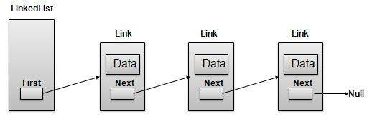

Each Link carries a data field(s) and a Link Field called next. Last Link carries a Link as null to mark the end of the list.

Types of Linked List

Simple Linked List − Item Navigation is forward only.

Doubly Linked List − Items can be navigated forward and backward way.

Circular Linked List − Last item contains link of the first element as next and and first element has link to last element as prev.

Insertion − add an element at the beginning of the list.

Deletion − delete an element at the beginning of the list.

Display − displaying complete list.

Search − search an element using given key.

Delete − delete an element using given key.

# Searching

Linear Search

start searching from 1st element of arrayuntil u find the no.

Binary Search

Says take middle of the element and given that array is sorted then element will lie to right or left of the middle element this happens at every step until middle element is your answer

Here we are not creating a copy of new array

Lets say we take k steps to reach ans then k = log2N where N is no. Of elements in the sample. The worst case in LS was N where as in BS its log2

Order agnostic binary Search

Here we check if the order is ascending or descending

The best way to do that is compare the first and last element. Here we assume that the given array is sorted

When ever we get a sorted array try binary search fierst 98% of the questions will be solved

Find the size of of box in sarray = end - start + 1

Ternary Search:-

Similar to binary search but divided in 3 parts. Time complexity – O(log3n)

Mid1 = s+(l-s+1)/3

Mid2 = l-(l-s+1)/3

Fibonacci search:-

Elements must be in sorted order.

Time complexity- log2N

Steps:

1. Find F(K){kth Fibonacci number). Which is greater than or equal to n

2. If F(K) = 0

stop and print message as element not found

3. Offset = -1

4. i= min(offset + F(k-2), n-1)

5. If S == A[i]

return i and stop the search

If S > A[i]

k = k-1, offset=i and repeat steps 4,5

If S <A[i]

k = k-2 repeat steps 4,5

Rotated_binary_search- 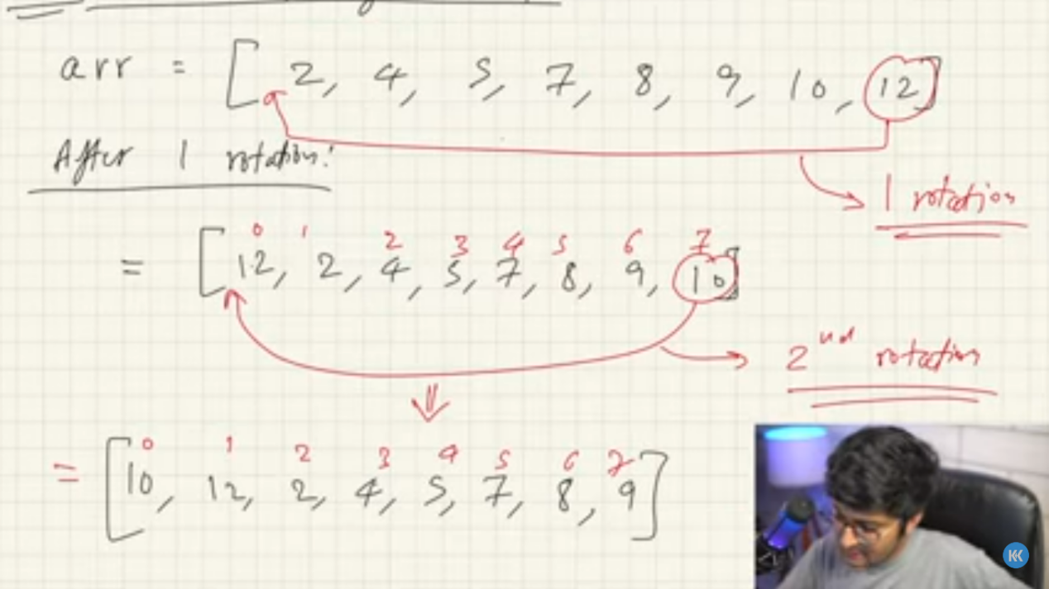

Searching in 2d Array/Matrices -

# Sorting

Bubble sort/Sinking sort/exchange sort Algorithm-

Here we compare each element to adjacent element if previous element is greater then we swap the elements. When we run the algo through entire array for 1st time the largest element goes to end after 2nd pass 2nd largest element goes at second last position. With each step the right part of array is sorted this means there is no need t compare that part

Here i I.e. outer loop acts as a counter we compare j with j-1

Best case - O(N) array is sorted in asc

Worst case - O(N2) - array is sorted in desc order

Inner loop will run until j<(length-i)

Outer loop will run until i<(length-1)

stable algorithm- if there are duplicates in array and the order of duplicates is maintained

Selection sort - here we select a element and the put it in its right position here are 2 ways

Select max element and put it at its position

Select min element and put it at its position

Insertion sort- here we sort a partial array

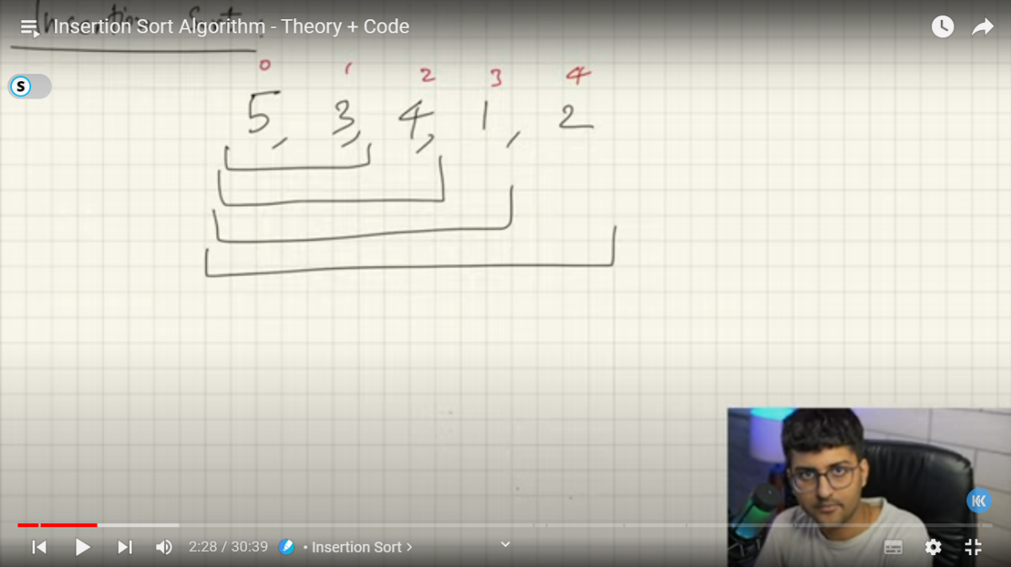

Why use insertion sort=> no. Of swaps reduced compared to bubble sort, its stable, works best when parts of array are sorted, used for small vales of N

Best case - O(N) array is sorted in asc

Worst case - O(N2) - array is sorted in desc order

Cyclic sort - its sorted in 1 single pass

When given nos from range 1 to N use this

So what we do is we check element at 0th position if it not at right position we dirrectly swap it to its right position then again we check first position and we swap until 1st position has right elements then we go to next position. In worst case it will have 2N-1 swaps

After sorting index = value-1mse

Strings - String is stored in a String pool in heap.

String pool - is a separate memory location in heap where we can store same strings.

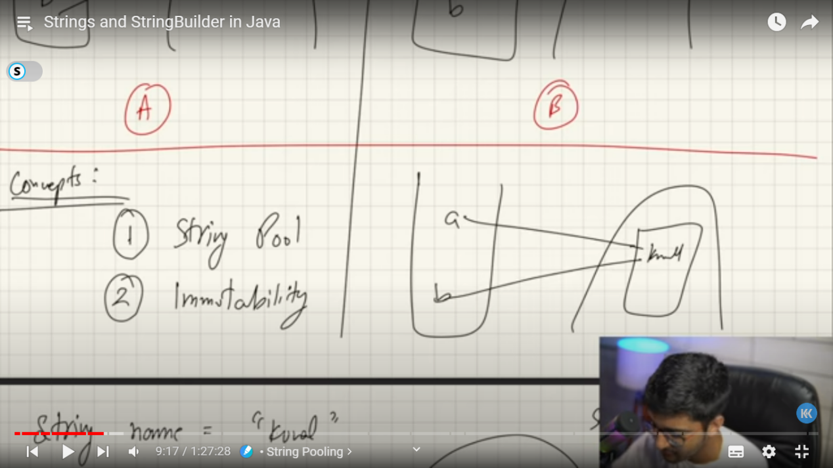

Strings are immutable on java

String a = "Kunal":

System.out.println(a);

a = "Kushwaba";

System.out.println(a);

Here we are changing the entire object

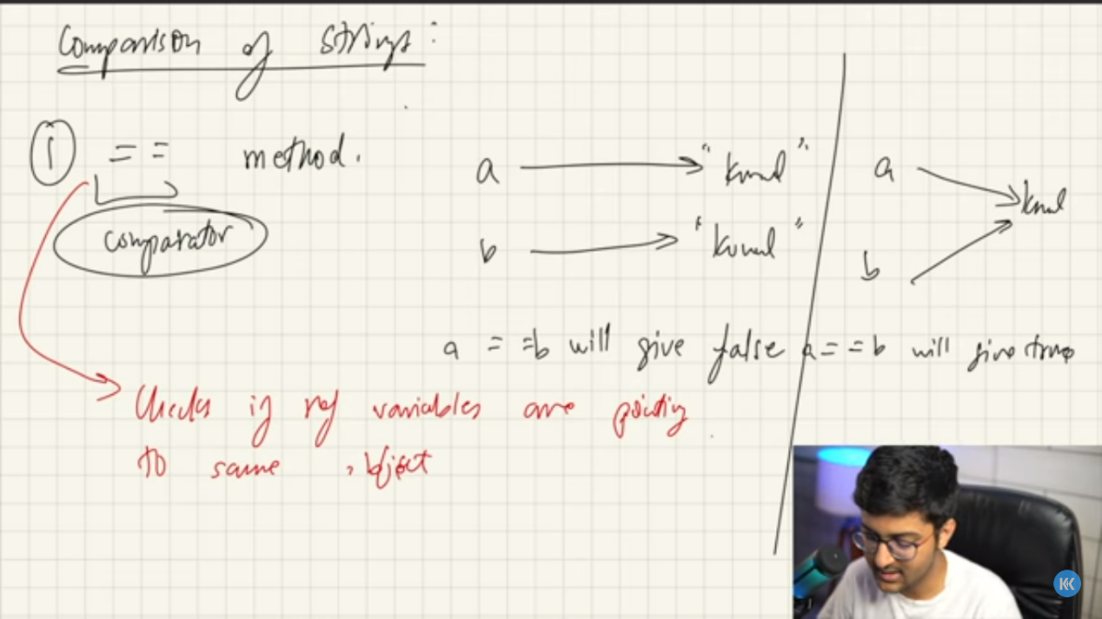

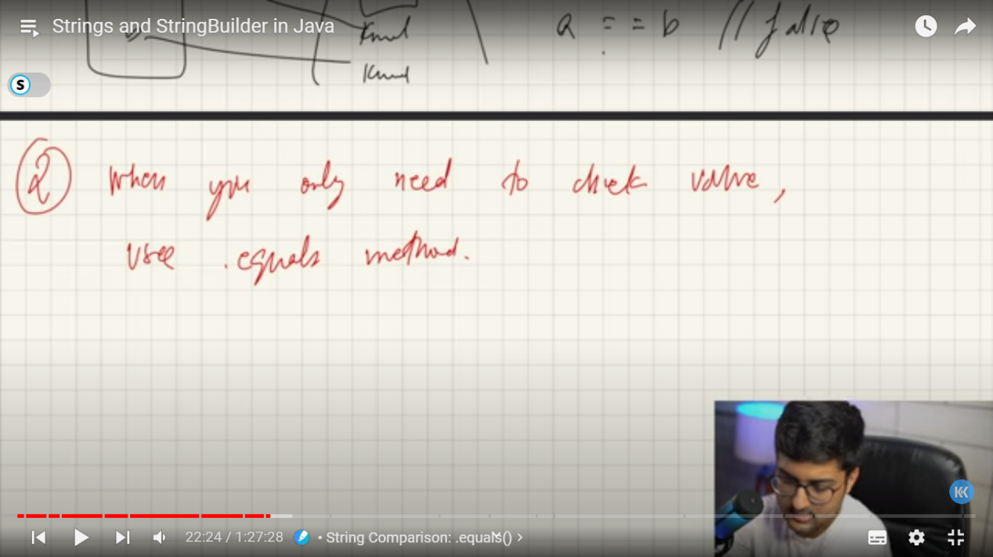

Whenever String is concatenated with integer, integer is converted to its wrapper class integer that will call .tostring() method

System.out.println("a" + 1); -> a1

Remember this whenever there is object created then it will call .tostring() method when concatenated with string

String builder- object is made and changes are done in that object only its mutable, its different class like string

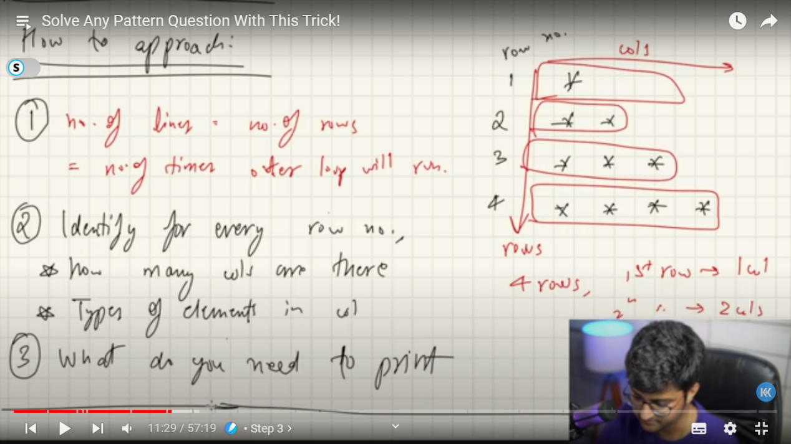

Recursion - (very imp)

All function calls happen in stack memory and until its not finished executing it will remain in stack memory. Once its finished executing its removed from stack and flow of program is restored to where it was called.

Recursion is function calling itself and the function will run until there is no condition applied that means that to terminate the program we should have a condition that is called as Base condition it’s a simple if condition

Remember even if its called from same function it will take separate memory in stack foe every recursive call

If there’s no base condition then we go on calling the function and a point will come when the memory of stack will become full thus we get stack overflow error

When to know that u can solve using recursion- if u can solve smaller version of the problem or when u have to find nth no. In series

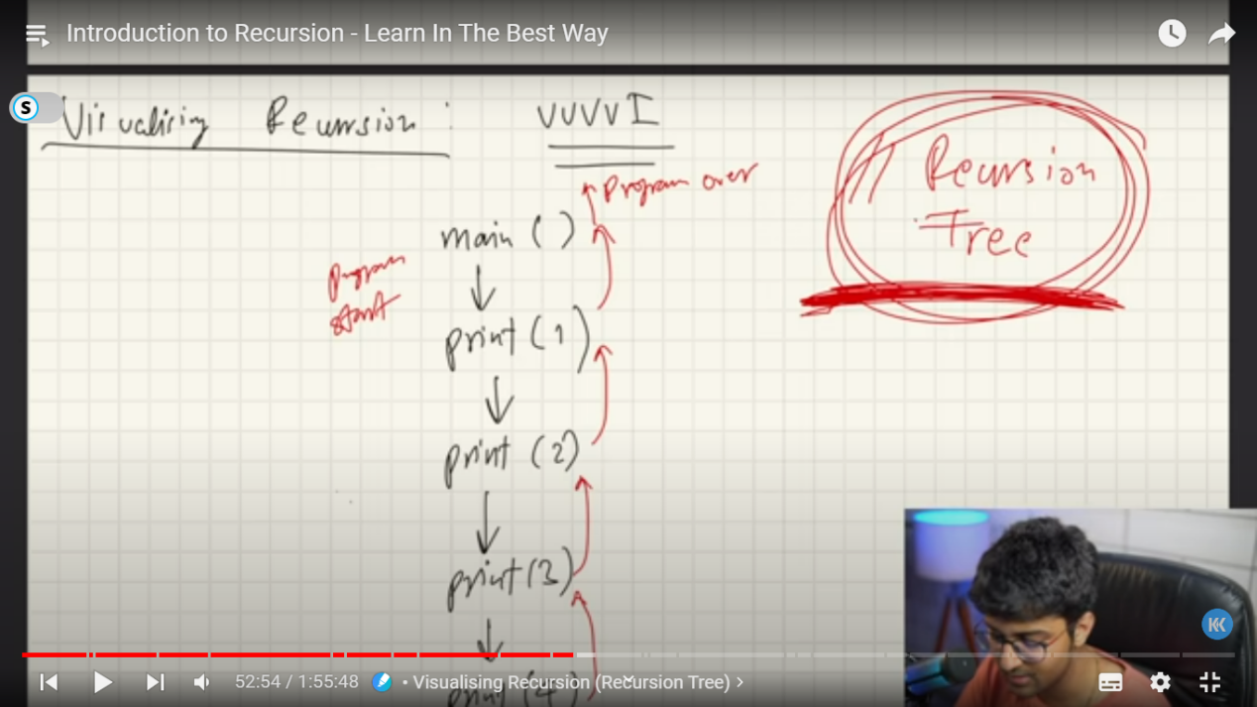

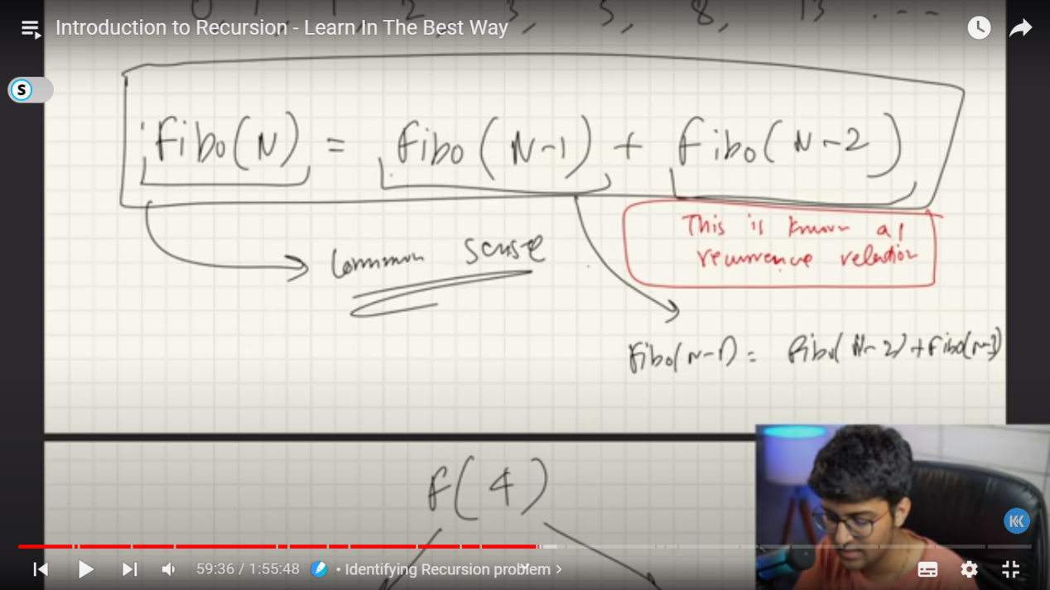

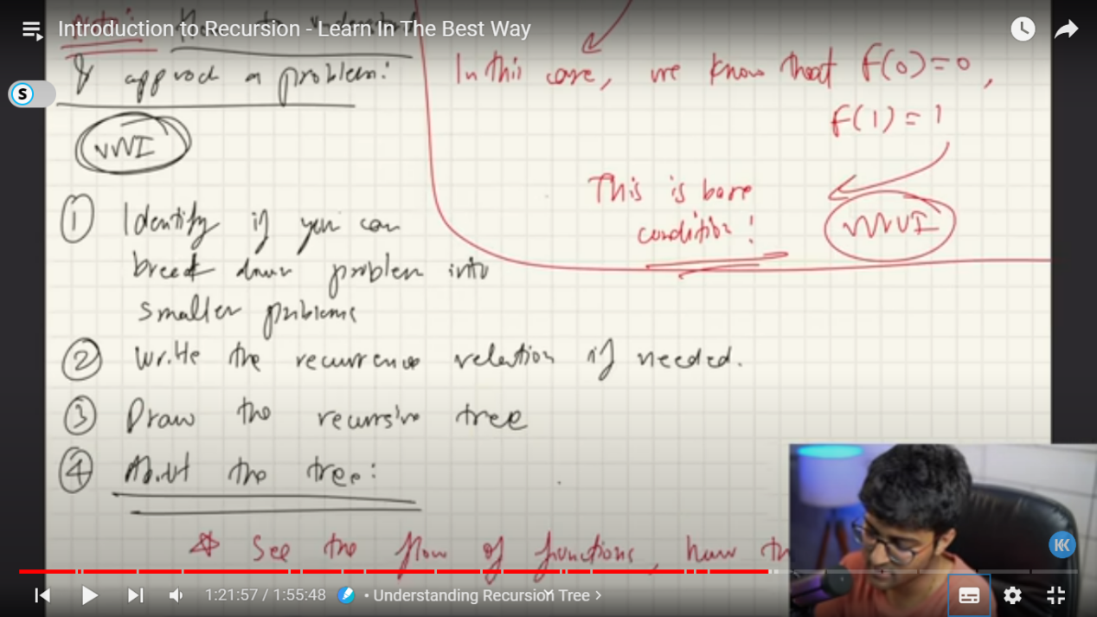

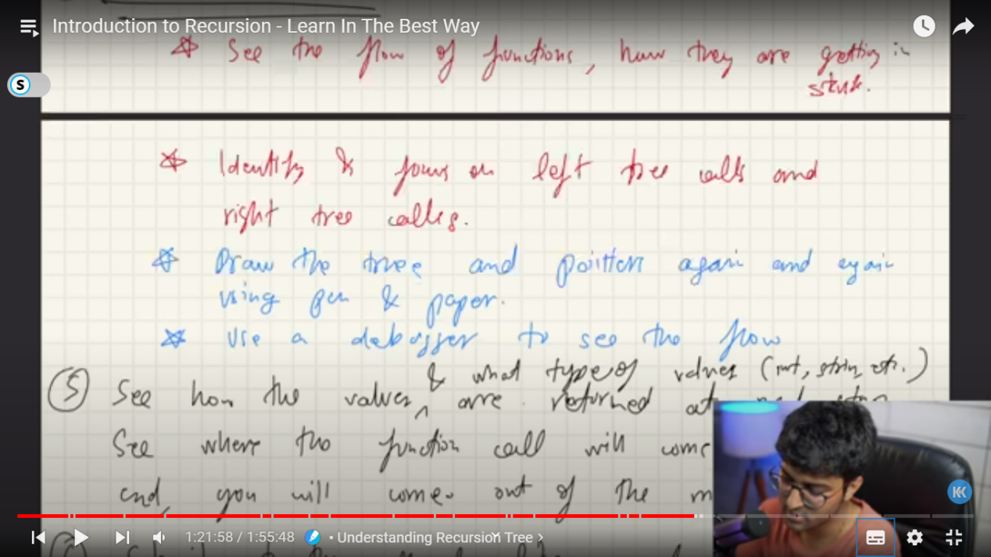

There are 3 variables -

argument vaiables- variables that u want to pass for future functions also

Body variables- variables that are limited to this function u want to pass but not required as they can be derived

Return type

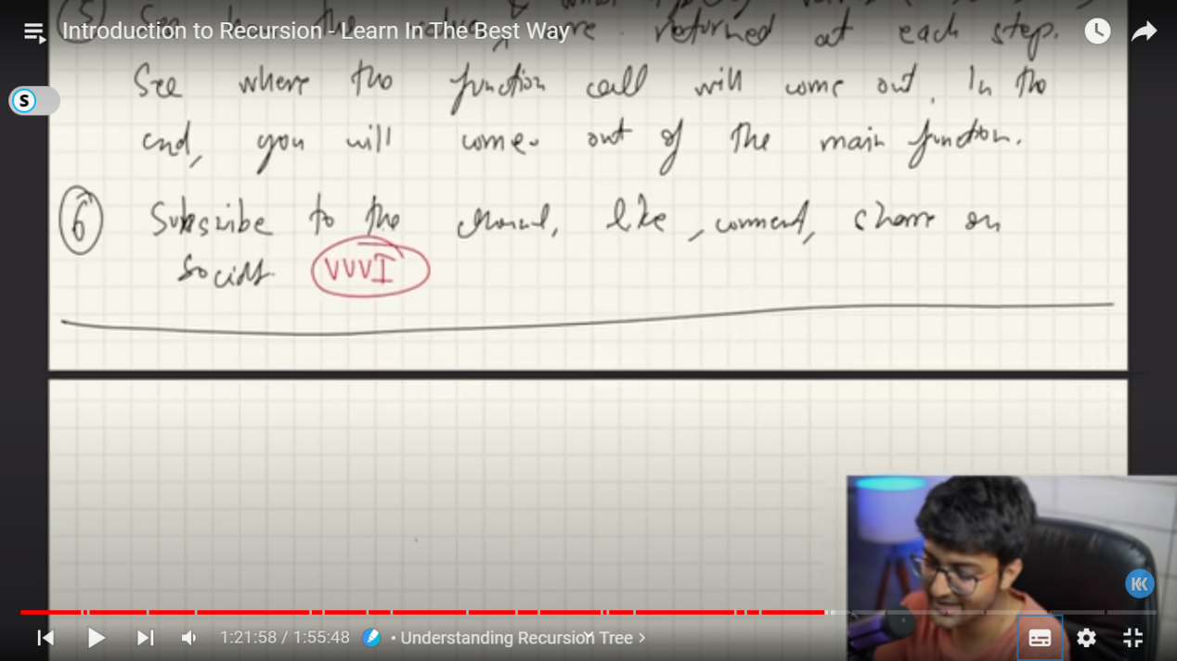

Binary Search using Recursion

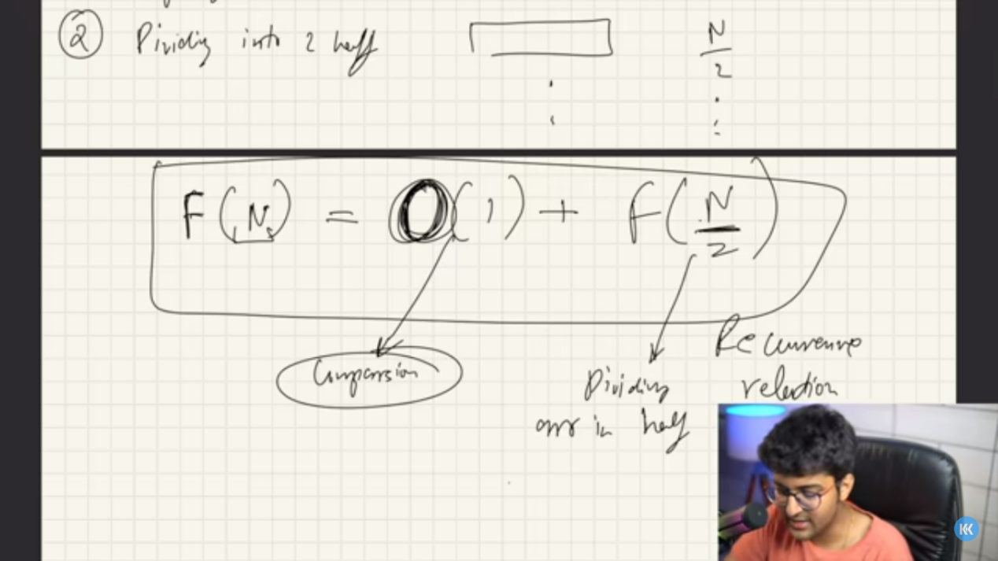

Merge Sort:-

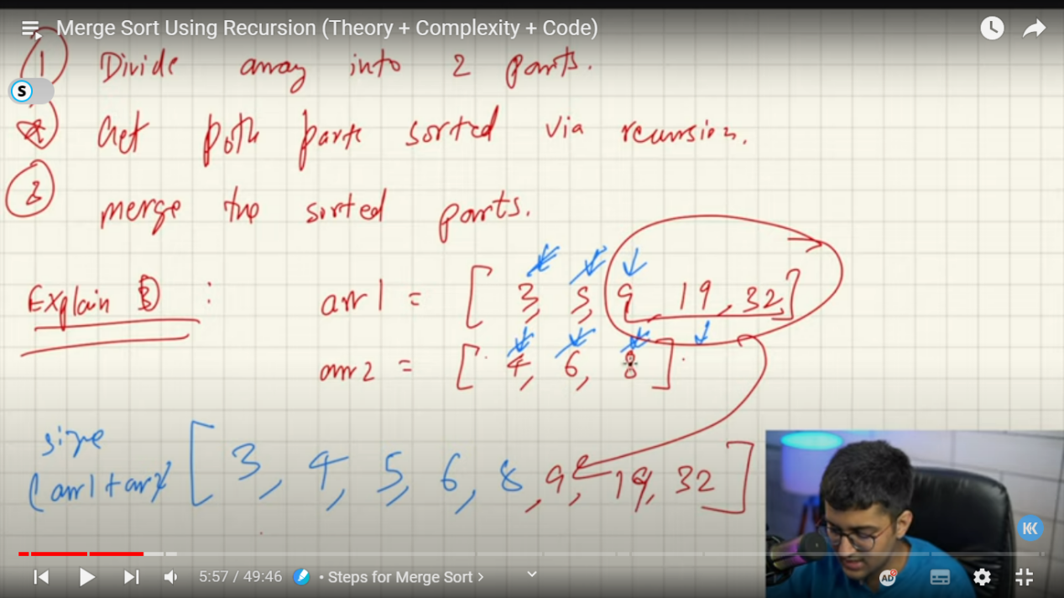,

In place Merge Sort:-if we don’t want to make copy of the array then we use this

Quick Sort:- (pq - pivot quick)

In this there is pivot element and after first pass all the elements smaller than pivot will be to the left of pivot and the elements greater will be to the right

This is when recursion will come in to play now we will call we again call merge sort to elements on right and to left then it will again choose a pivot

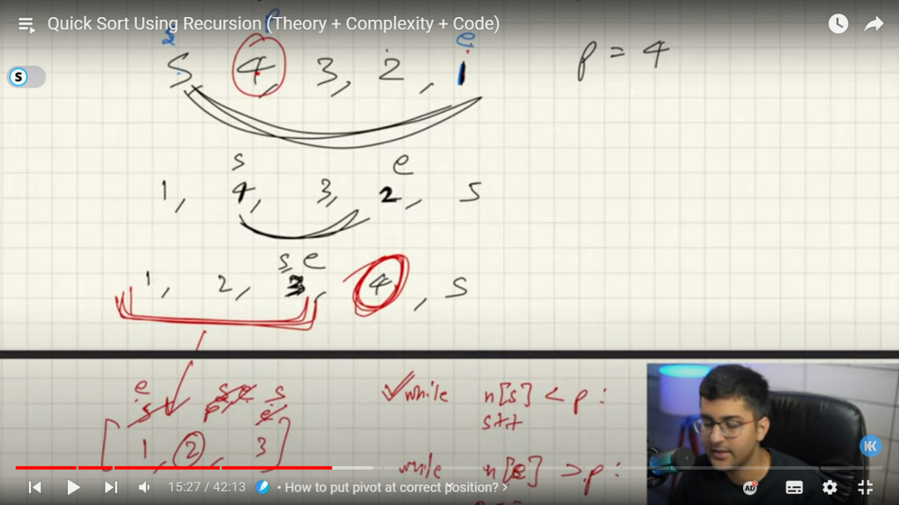

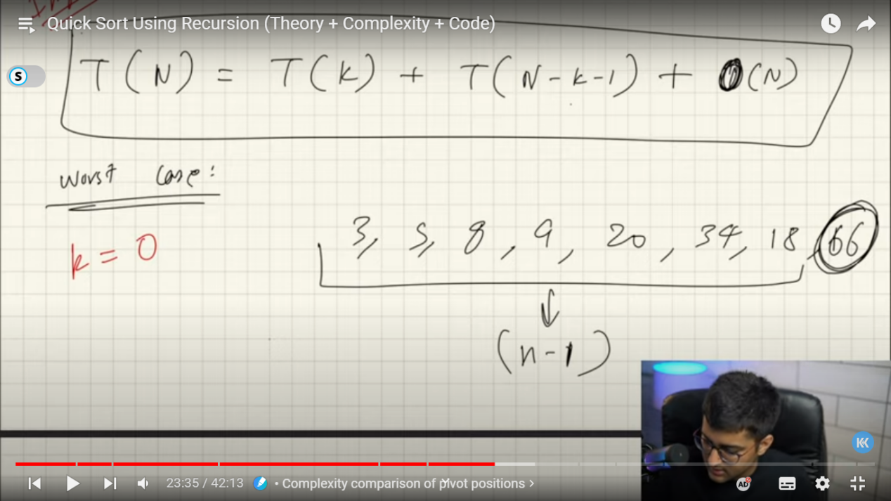

Worst case when pivot element is at start or end becoz the recursion increases

Best case is when it gets divided into 2 hals that is middle element

Stacks- follow FILO,

Time complexity - constant

Stack Is a class

Queue -follow FIFO

Queue is a interface

So we cant create the object, so we useArray deque or we can also use linked list to create the array.

Deque has resizable arrayit can add or remove from both sides. Its faster than linked list and stack

Research yourself= hybrid sorting eg.- pin sort I.e. merge + insertion sort

Linked List --

Its just like array or arraylist but only thing here is elements here are not in continuous manner its addresses are randomly stored and they are connected to each other via arrows. Every element is known as node

Single linked list -

In here we only one has crush on other

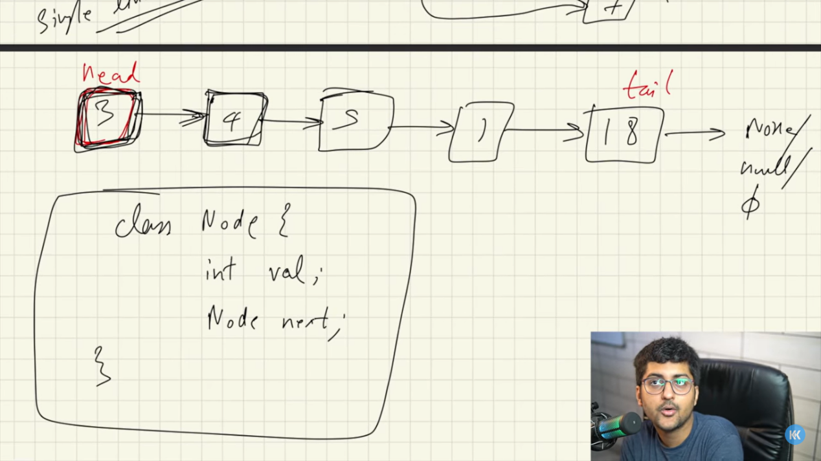

Doubly linked list -

Circular linked list -

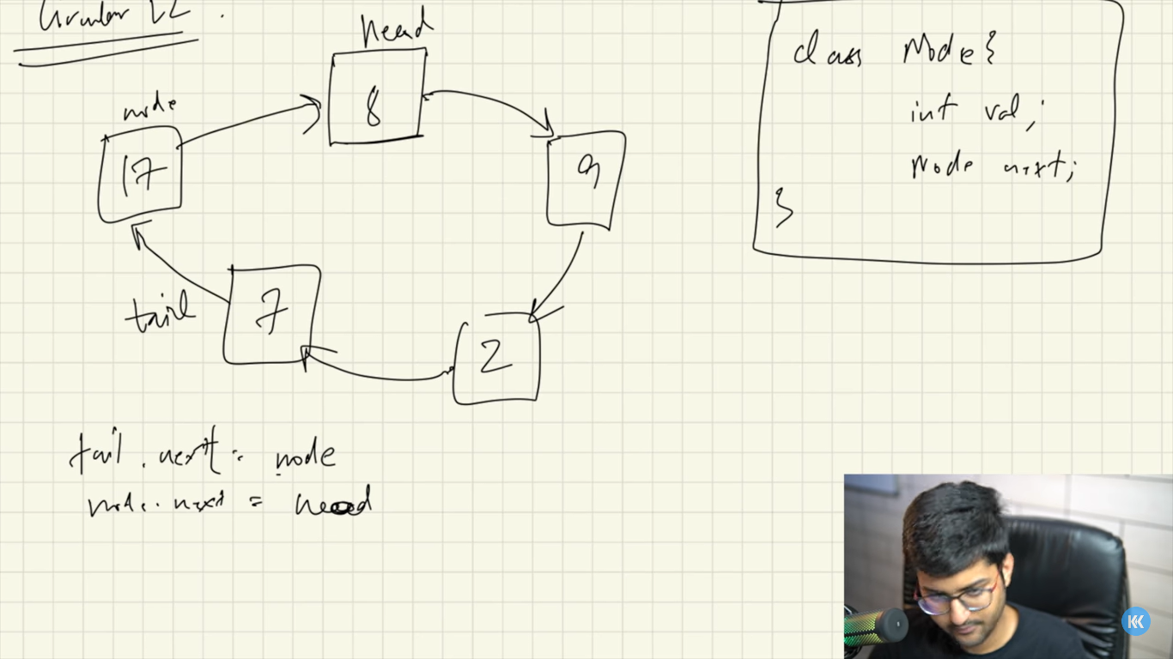

Trees:-

It has multiple levels it has hierarchy. Its non-linear data structure.

Leaf nodes are thoese that have no child nodes. Also known as external nodes

Degree of node = max no. of child nodes tp a parent

Depth of node- length of path from root to that node. Or no. of edges

Height of tree – no. of edges from root to longest leaf node

Maximum number of nodes in a binary tree of height ‘h’ is 2h – 1

height or minimum number of levels is Log2 (N+1)

If there are n nodes then there will be n-1 edges

A full binary tree (sometimes proper binary tree or 2-tree) is a tree in which every node other than the leaves has two children. A complete binary tree is a binary tree in which every level, except possibly the last, is completely filled, and all nodes are as far left as possible.

Binary tree- each node can have at max 2 child nodes

Total no. pf nodes on level h is – (2h+1-1)

Min no. of nodes at level h is – h+1

To find nodes when height is give take log and solve the equation and then take the ceil function

Full binary tree – contains either 0 or 2 children

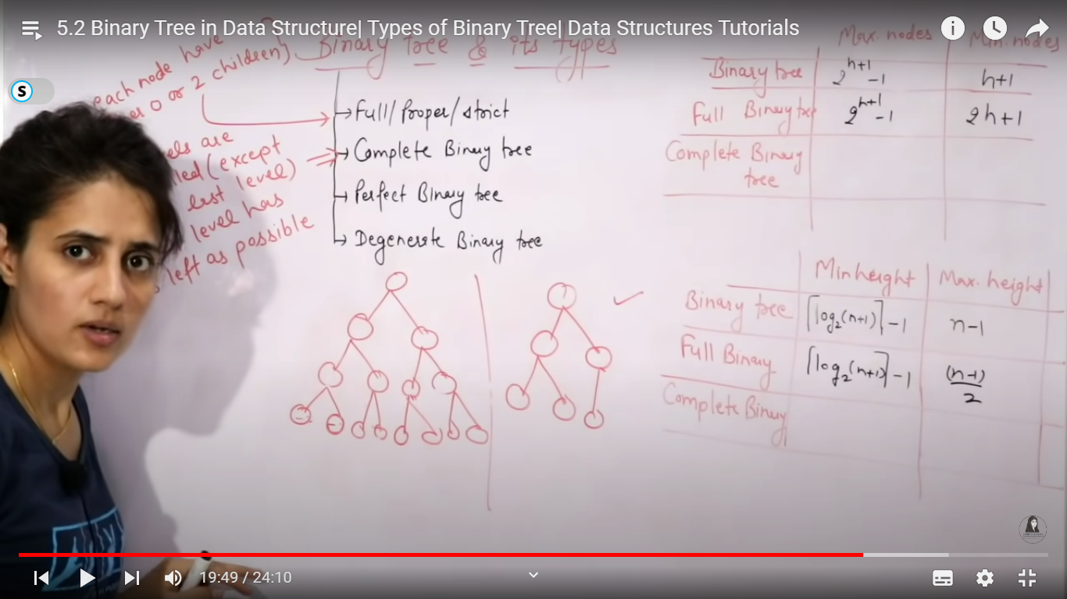

Perfect binary tree- 2 children and all leaves at same level

Degenerate tree – all internal nodes have 1 child

Sequential representation – parent node i

Left node – (2*i)+1

Right node – (2*i)+2

Avll trees:- Bt take O(h) time where h is the height of the BST. • The cost of these operations may become O(n) for a skewed Binary tree. • If we make sure that height of the tree remains O(Logn) after every insertion and deletion, then we can guarantee an upper bound of O(Logn) for all these operations. • The height of an AVL tree is always O(Logn) where n is the number of nodes in the tree.

• AVL tree is a self-balancing Binary Search Tree (BST) where the difference between heights of left and right subtrees cannot be more than one for all nodes. • A binary search tree is said to be AVL balanced if: – The difference in the heights between the left and right sub-trees is at most 1,

Threaded Trees • Binary trees have a lot of wasted space: the leaf nodes each have 2 null pointers • We can use these pointers to help us in inorder traversals • We have the pointers reference the next node in an inorder traversal; called threads • We need to know if a pointer is an actual link or a thread, so we keep a boolean for each pointer

. The idea of threaded binary trees is to make inorder traversal faster and do it without stack and without recursion. A binary tree is made threaded by making all right child pointers that would normally be NULL point to the inorder successor of the

Single Threaded: Where a NULL right pointers is made to point to the inorder successor (if successor exists) • Double Threaded: Where both left and right NULL pointers are made to point to inorder predecessor and inorder successor respectively. The predecessor threads are useful for reverse inorder traversal and postorder traversal.

Graphs:- there are 2 ways to represent a graph

Adjacency matrix – space complexity – n2

Adjacency list – for every node one linked list will be maintained. space complexity – n+2e

Better to use adjacency matrix for dense graph and adjacency list for sparse graphf

Spanning tree-

When you convert a graph into tree such that it contains n nodes and n-1 edges where all the nodes are reachable then it called a spanning tree. The one with minimum weight is called minimum spanning tree

Properties:

Removing a single edge from spaning tree will make it disconnected

Adding a single edge will create a loop

A complete undirected graph will have nn-2 spanning trees(st)

Disconnected grakph don’t have st

From complete graph by removing e-n+1 graph we can create a st

Spanning tree doesnot cantain any cycles

Prims algo:-

Kruskals algo:-

Hashing:- Method of storing and retrieving data from database in constant time. Data Structure which is designed to use a special function called the Hash function • It is used to map a given value with a particular key for faster access of eleme. Array that stores pointers to records corresponding to a given phone number.

Hash table- Array that stores pointers to records corresponding to a given phone number. • Collision Handling-Hash function gets us a small number for a big key, there is possibility that two keys result in same value. Newly inserted key maps to an already occupied slot in hash table is called collision

Chaining: – The idea is to make each cell of hash table point to a linked list of records that have same hash function value. – Chaining is simple, but requires additional memory outside the table. • Open Addressing: – In open addressing, all elements are stored in the hash table itself. – Each table entry contains either a record or NIL. – When searching for an element, we one by one examine table slots until the desired element is found or it is clear that the element is not in the table.

# Greedy Aalgorithms

To find optimized approach there are 2 ways

1. Greedy algorithms
2. Dynamic Programing